**Problem :** [**https://leetcode.com/problems/clone-graph/**](https://leetcode.com/problems/clone-graph/)

**Approach :**

-> Do a BFS.

-> **One thing which is tricky here is we need to maintain the**

**Mapping of all the values Seen until now to the address generated for them for the 2nd graph.**

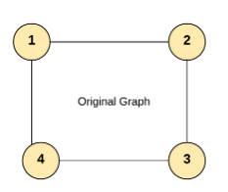

E.g : for this graph when we do a BFS , first node popped from queue is 1.And we generate a new pointer for node 1 for 2nd graph.So we need a mapping {1,address}.Now a new address needs to be generated for node 2 as its not already seen before and same for 4

Now adj[1].pushback(2) and adj[2].pushback(1), and we store address for 2 & same with 3, why? See below:

Now bcoz it’s an undirected graph , when we visit the node 2 we generate a new address for 3 as its not alread seen, 1 is already visited so no need to process it , so just

store adj[2].pushback(3), adj[3].pushback(2).

**Now bcoz we saw node 3 , we map the address {3,address}, so that when we go to visit 4, 4 will not generate a new address to 3, it first sees that map[3] is filled or not,and here it’s filled as we already generated a pointer for it when we saw it from 2,so** adj[4].pushback(3), adj[3].pushback(4) , will use old address of 3 only, if you generate a new address , then value of adj[3]=2 is lost as now we have no reference to old address of 3.

**Code :** [**https://leetcode.com/problems/clone-graph/submissions/**](https://leetcode.com/problems/clone-graph/submissions/)